**Weekly Summary (08-05-2025)**

**What I did:**

* Tried changing the calibration offsets to reduce the YPR drift. Did not yield significant results. Decided to focus on getting angles from raw acceleration values
* Found out true YPR movements and verified them with MPU 6050 documentation.
* Created an Arduino sketch which outputs only pitch and roll angles from the accelerometer readings (can be helpful in knowing the sensor’s calibration and accuracy)
* Categorized previous data based on the presence of accelerometer readings
* Applied butter filter to the previous measurements and found the best suited filtering parameters through trial and error
* Plotted all the previous measurements with filtered accelerometer readings
* Described the important aspects and key trends of each measurement done previously
* Replicated some of the static measurements done previously and obtained similar angle variations.

**Problems I faced:**

* Not able to get the exact angle but able to capture the change in angle with extension with good accuracy.

**Possibilities for future tasks:**

* Completing the BOSCH device deflection measurements for 14.3 Kgs
* iPhone recordings of 8.1 Kgs and 14.3 Kgs with and without weights at an extension range of 112 cm to 157 cm
* Simulate the previously done static measurements exactly in the lab and compare both the measurements
* Proceeding with the actual measurements if calibration seems to be proper

**Plots and pictures:**

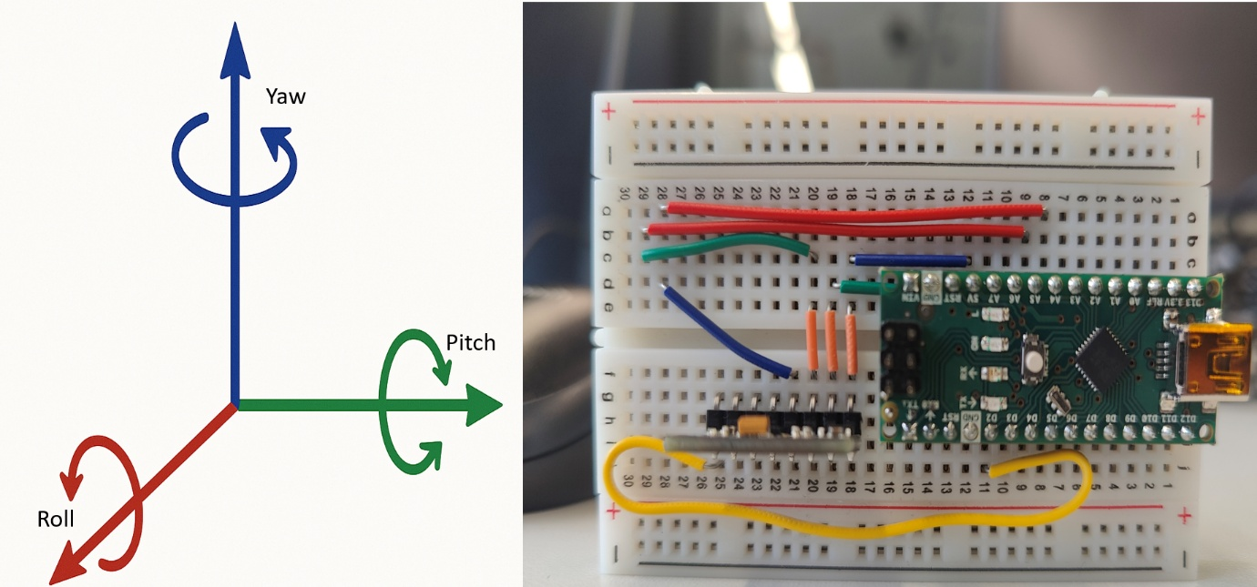

**Fig:** YPR configuration

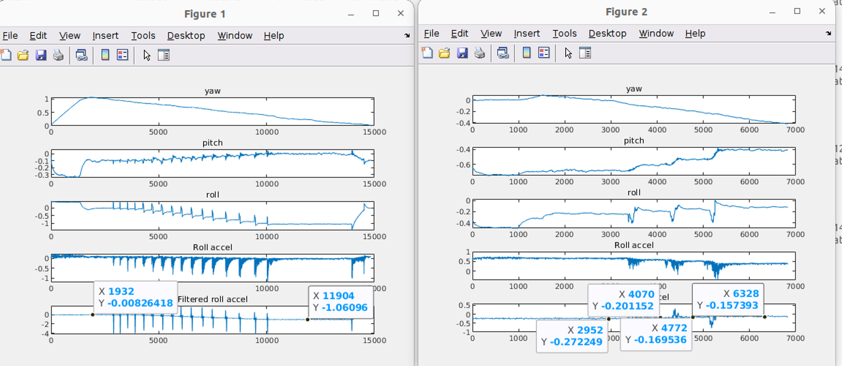

**Fig:** Figure 1 (Previously measured data from extensions 0 to 1240 mm) and figure 2 (Measured in lab from 900 mm to 1240 mm)